**Chris Evans retired as Captain America**

[](https://4.bp.blogspot.com/-La72xaSeilM/W7g6Y7H13zI/AAAAAAAAAJI/h5c-cO5sba0Te0KLYsU77LVvGHdIQ3wiACLcBGAs/s1600/chris_evans_gettyimages-663618986_1280.jpg)

**On Thursday,**

[Chris Evans](https://en.wikipedia.org/wiki/Chris_Evans_(actor)) aka Captain America posted a [tweet](https://twitter.com/ChrisEvans/status/1047896966410190849) that,

Officially wrapped on Avengers 4. It was an emotional day, to say the least. Playing this role over the last 8 years has been an honour. To everyone in front of the camera, behind the camera, and in the audience, thank you for the memories! Eternally grateful.

[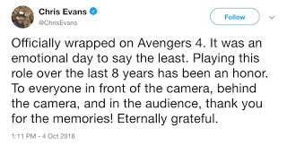](https://2.bp.blogspot.com/-vYcdWCRAnQg/W7g6pEB0KgI/AAAAAAAAAJQ/dhjBuGwpvfQAQ_nNGB9-u-lakdNTtWhEQCLcBGAs/s1600/Screen-Shot-2018-10-04-at-4%2B%25281%2529.webp)

**Full name:** Christopher Robert Evans.

**Born:** June 13, 1981.

**Evans** is known for his superhero roles in the [Marvel Cinematic Universe](https://en.wikipedia.org/wiki/Marvel_Cinematic_Universe) aka **MCU**. His first MCU role was "[Human Torch](https://en.wikipedia.org/wiki/Human_Torch)" in Fantastic Four and also in its sequel. He works with MCU about a decade.

[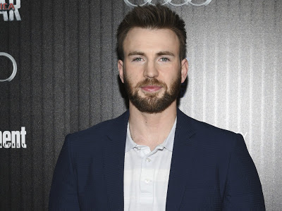](https://2.bp.blogspot.com/-35GRyVVhId0/W7g9HkwpmaI/AAAAAAAAAJs/8SgIrFh1Ru4snIhIjEbGnykw46Hq6ktswCLcBGAs/s1600/0e810647e8824138b5a1d47dacc2366e-0e810647e8824138b5a1d47dacc2366e-0-cpt636742664565409298-e1538689559220.jpg)

**MCU Movie's played by Chris Evans:**

* The First Avenger: Captain America
* Avengers
* Captain America: The Winter Soldier
* Avengers: Age Of Ultron
* Captain America: Civil War
* Avengers: Infinity War
* Avengers: Infinity war 2
* Fantastic Four
* Fantastic Four 2
* (Also some cameo in MCU)

**Chris Evans entering in MCU:**

In 2005, Evans played the role of **"Human Torch"** in Fantastic Four. It was his first work with Marvel. On that time MCU was not in the best position. Then in 2007 Evans played again as "Human Torch" in the sequel of Fantastic Four.

After releasing of **"**[**Iron Man**](https://en.wikipedia.org/wiki/Iron_Man_(2008_film))**"** Marvel Cinematic Universe was at the top of the audience favourite chart. Then Marvel offers Chris Evans to play the role of Captain America in the film **"**[**Captain America: The First Avenger**](https://en.wikipedia.org/wiki/Captain_America:_The_First_Avenger)**"**.

Everyone was afraid that will it suit with Chris Evans?? Also about the approach of Chris Evans for playing the role. Some say that it was his mother who convince Evans for playing the role. The film brings a whole new set of audience to the MCU.

**Evans Role As Captain America:**

In the first film of **Captain America**, his role was about an honourable man who just wanted to join US Army and fight against the Nazi's in the second world war. For that, he was injected by a serum which turned him into a super soldier. He fought with aliens, robots and also with [Bucky Burnes](https://en.wikipedia.org/wiki/Bucky_Barnes) aka The Winter Soldier. He always controlled the Avengers in all **The Avengers** movies.

[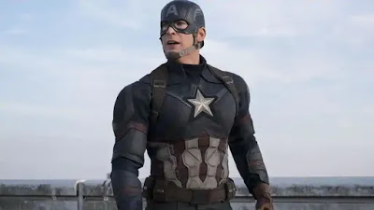](https://4.bp.blogspot.com/-RgVRo_F25wk/W7g9TROmo2I/AAAAAAAAAJw/2dfKY-d4Mj0n2u1yVJKXBmd7mhPwlGyMACLcBGAs/s1600/_fb4d0394-c853-11e8-978e-6307977af0b0.jpg)

**Cause of retirement as cap:**

Once Evans said that **"You want to get off the train before they push you off"**. It means it was known that Evans will say goodbye to Marvel. There is also another reason. MCU's phase three of superheroes will end. We know that after Avengers 4 a lot of character will be out of contract. MCU will be bringing some new superheroes. And also there is a chance for a new captain. If a new captain rise then it will be superhero [**Winter Soldier**](https://en.wikipedia.org/wiki/Bucky_Barnes) or [**Falcon**](https://en.wikipedia.org/wiki/Falcon_(comics)). We have to wait until next year for releasing of Avenger 4.

**Evans upcoming works:**

Evans has now joined with the [**Knives Out**](https://www.imdb.com/title/tt8946378/), the new film from [Rian Johnson](https://en.wikipedia.org/wiki/Rian_Johnson).

**Other Celebs Reaction:**

Superhero " [Deadpool](https://en.wikipedia.org/wiki/Deadpool_(film))" actor [**Ryan Reynolds**](https://en.wikipedia.org/wiki/Ryan_Reynolds) was also depressed because of Evans goodbye to Marvel Universe. He tweeted that,

I'm not crying, I'm weeping. There's a difference

[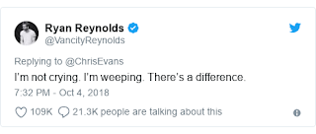](https://4.bp.blogspot.com/-dEFr0Ui7KqA/W7g8gI3o9iI/AAAAAAAAAJc/ktA8mgx6troeQT3Hg9ZGmNWHIGdzzqFkgCLcBGAs/s1600/newsbeat-45756235.png)

[**Dwayne Johnson**](https://en.wikipedia.org/wiki/Dwayne_Johnson) aka **The Rock** tweeted that,

What a run you had brother. Congrats on breathing life into such an iconic character keep on keepin' on

[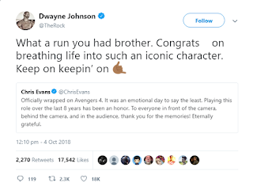](https://3.bp.blogspot.com/-4FwK-R1uGOg/W7g8t8LVFDI/AAAAAAAAAJg/xaDNkBmqoDYHnlhcHWlZXgJyQDho2Sh4ACLcBGAs/s1600/screenshot-twitter.com-2018.10.06-10-24-49.png)

Chris Evans role as Steve Rogers, as Captain America will never be forgotten. We will miss you captain. You will be always our captain.